**Computer Vision**

# Digital image

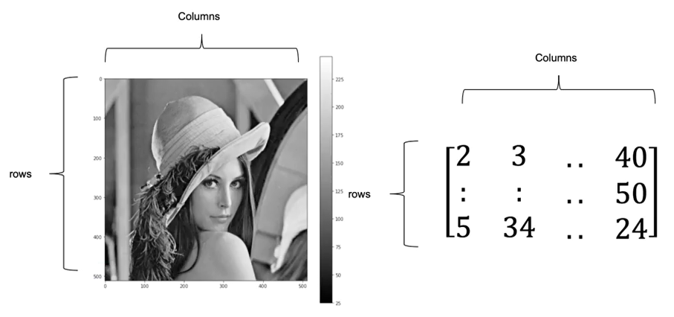A **digital image** is a numerical representation of a visual scene, typically stored as a grid of pixels. Each pixel has specific colour and intensity values, which collectively form the image.